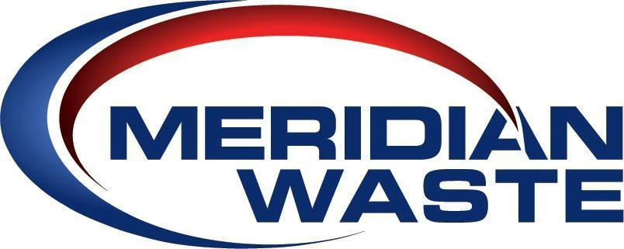

Don Kindig Joins Meridian Waste Eagle Ridge Landfill As New General Manager

Bowling Green, MO (July 18, 2022) – Meridian Waste, an integrated, non-hazardous solid waste services company, announced today the hiring of Don Kindig as General Manager of Eagle Ridge Landfill and Bowling Green Hauling effective July 11.

Kindig comes to Meridian Waste as a solid waste industry veteran with more than 30 years of operating and managing landfills, transfer stations, and material recovery facilities (MRFs). Kindig’s professional career in waste management began following his honorable discharge from the U.S. Army in 1991 and a six-year construction job. Kindig started his environmental services occupation with Attwoods Environmental and held positions with leading solid waste companies including BFI Waste Systems, Allied Waste, Republic Services, and Advanced Disposal. He worked with current Meridian Waste leadership while serving as general manager of the Jones Road C&D Landfill in Jacksonville, FL, ECO Safe Landfill in Bristol, TN, Hoosier Landfill in Evansville, IN, and Arbor Hills Landfill in Detroit, MI.

“Don brings a wealth of experience to our Missouri team and is extremely capable of managing our Eagle Ridge Landfill and Bowling Green hauling assets in an environmentally safe and efficient manner,” stated Gregg Ascuitto, Meridian Waste’s Area President in Missouri. “His operational knowledge and commitment to the community in surrounding disposal facilities makes Don a standout among his peers,” he said. “I believe Pike County has a gained a great advocate for a beautiful and healthy environment with Don’s addition to the Meridian Waste team.”

Eagle Ridge Landfill is one of Pike County’s strongest economic leaders employing 13 individuals, and has paid the County $342,680 in annual host fees and property taxes since Meridian Waste Acquisitions, LLC purchased the disposal facility in 2018.

more...

PHOTO 1: July 2022 landfill cell construction at Eagle Ridge Landfill.

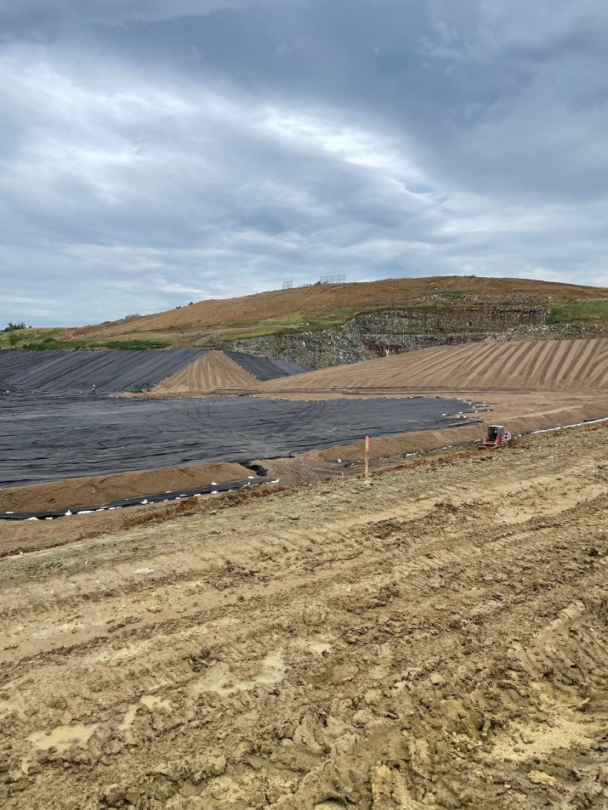

About Meridian Waste
Headquartered in Charlotte, N.C., Meridian Waste is a company defined by its commitment to servicing its customers, caring for and engaging its employees, and generating financial value for its shareholders while delivering a clean and healthy community. The company’s core waste business is centered on residential, commercial, and industrial non-hazardous solid waste collection and disposal. Currently, the company operates in Northeast Fla., St. Louis, Mo., Raleigh, N.C., Goldston, N.C., Greenville, S.C., Knoxville, Tenn., Blacksburg, Va., Harrisonburg, Va., and Richmond, Va. servicing more than 203,343 residential, commercial, industrial, and governmental customers. In addition to a fleet of commercial, residential, and roll-off trucks, the company operates 13 hauling companies, eight transfer stations/materials recycling facilities (MRFs), two municipal solid waste landfills, and three C&D landfills in which 845,110 tons of waste are safely disposed of annually. For more information, visit MeridianWaste.com.

Media Contact:
Mary O’Brien
(904) 616-5322
MObrien@MeridianWaste.com

