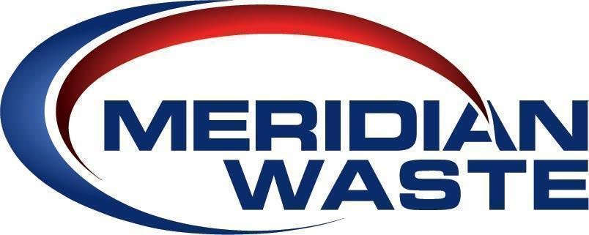
FOR IMMEDIATE RELEASE
February 6, 2023

MERIDIAN WASTE’S ASHLEIGH GARNES NAMED TO
WASTE 360’s 2023 40 UNDER 40 AWARDS LIST

- Recognized as a Next-Generation Leader in the Waste and Recycling Industry -

Christiansburg, Va. (February 6, 2023) – Meridian Waste today announces Ashleigh Garnes, General Manager, has been named to Waste360’s 2023 40 Under 40 awards list, which showcases the next-generation of leaders in waste and recycling who are shaping the future of the industry.

Garnes has been in the environmental services industry for five years after being recruited by Meridian Waste for her leadership in the community, sales experience, comprehensive business and personal network, impressive energy, and commitment to quality work.

Under Garnes’s leadership, Meridian Waste has become the primary environmental services provider for Virginia Tech. Throughout the partnership, Ashleigh has become a board member of the Climate Action Commitment Team, comprised of Virginia Tech leadership, students, and the community. They have increased the recycling of old corrugated cardboard (OCC), single stream recycling, and compost with a 43 percent increase from 29 percent in 2020.

The collaboration with Virginia Tech stakeholders has allowed Garnes to establish new opportunities, events, and serve as a voice in the new construction of buildings. She oversees the Meridian Waste team and their work objectives, accomplishments, and diligence in achieving a common goal. Garnes takes the initiative to communicate with the university in planning and implementation of strategic and solution-driven processes while overcoming challenges on a college campus.

“Ashleigh is a woman succeeding in a predominantly male-dominated industry,” said Mary O’Brien, Meridian Waste’s Chief Marketing Officer. “Her approach includes learning the business from the ground up, and to understand and respect each employee as they positively impact the success of the company along with the customers they serve,” she said. “Her energy and passion for the community and Virginia Tech as her alma mater is proven in her work product.”

more...

The Waste360 40 Under 40 awards program recognizes inspiring and innovative professionals under the age of 40 whose work in the waste and recycling industry has made a significant contribution to the industry. The winners are involved in every part of the waste and recycling industry, including haulers, municipalities, composters, recycling professionals, policymakers, and product suppliers. A panel of expert judges from Waste360 evaluated the nominations and consulted with an external advisor to select the finalists and winners.

The winners will be honored during an awards ceremony at WasteExpo, North America's largest solid waste, recycling and organics industry event to be held from May 1 until May 4 in New Orleans, LA.

About Meridian Waste
Headquartered in Charlotte, N.C., Meridian Waste is a company defined by its commitment to servicing its customers, caring for and engaging its employees, and generating financial value for its shareholders while delivering a clean and healthy community. The company’s core waste business is centered on residential, commercial, and industrial non-hazardous waste collection and disposal. Currently, the company operates in Northeast Fla., St. Louis, Mo., Goldston, N.C., Raleigh, N.C., Greenville, S.C., Knoxville, Tenn., Blacksburg, Va., Harrisonburg, Va., and Richmond, Va., servicing more than 215,388 residential, commercial, industrial, and governmental customers. In addition to a fleet of commercial, residential, and roll-off trucks, the company operates 13 hauling companies, six transfer stations/materials recycling facilities (MRFs), two municipal solid waste landfills, and three C&D landfills in which 771,183 tons of waste are safely disposed of annually. For more information, visit MeridianWaste.com.

About WasteExpo
WasteExpo is the leading event in North America for waste, recycling and organics professionals from the private and public sector. WasteExpo offers an interactive conference program that dives deep into vital industry topics such as recycling, landfills, fleet management, collections, organics, safety, food waste and recovery, and more. WasteExpo also boasts a robust Exhibit Hall showcasing hundreds of exhibitors and the latest industry solutions. WasteExpo is co-located with the Waste360 Investor Summit, the Waste360 Healthcare Waste Conference, the Waste360 Business Leadership Forum and Waste360 Sustainability Talks.

more...
About the Waste360 Group
The Waste360 Group harnesses the power of its many properties to serve the solid waste and recycling industry. The industry widely consumes this content in the form of websites, live events, online learning and digital opportunities and includes: Waste360.com, WasteExpo, The Global Waste Management Symposium and topical and timely eNewsletters including Waste360 Daily Wire. Waste360’s NothingWasted! Podcast features the rockstars of the waste, recycling and organics industry weekly for the latest news and insights on people behind the industry. For more information, visit www.waste360.com.

Contact:
Mary O’Brien
(904) 616-5322
MObrien@MeridianWaste.com

###

