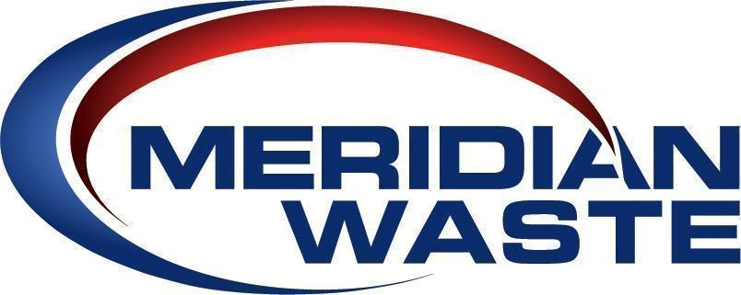
FOR IMMEDIATE RELEASE
December 1, 2021

LOCAL CHARITIES RECEIVE DOUBLE THE BENEFIT FROM THE 2021 SHOTWELL LANDFILL CHARITY PUMPKIN PATCH

- Meridian Waste Delivers Donation Checks on Giving Tuesday -

RALEIGH, N.C. (December 1, 2021) – Meridian Waste, an integrated, non-hazardous solid waste services company, strategically donated the proceeds of the 2021 Shotwell Landfill Charity Pumpkin Patch on Giving Tuesday, effectively doubling the financial benefit of the donations to the East Wake Education Foundation, Good Hope Baptist Church, and the Triangle Conservancy. All three charities are located in the Wendell community and are nearby neighbors of the disposal facility.

Meridian Waste began the Shotwell Landfill Charity Pumpkin Patch in October 2020. It continued activities on all five Saturdays in October 2021 due to the popularity of the initial event and increased involvement by residents of the local community. The 2021 Charity Pumpkin Patch expanded event activities to include a bounce house obstacle course, pumpkin and face painting, corn hole games, hayride tours, and touch-a-truck display.

Charity funds were raised by Meridian Waste purchasing pumpkins in three sizes with suggested donations of $5 for medium, $10 for large, and $15 for an extra-large pumpkin. Donations were suggested, however not required to visit the facility and enjoy the activities. Meridian Waste donated 100 percent of monies raised from the pumpkin donations, including a matching donation from Meridian Waste’s headquarters to double the amount given to the local charities. The decision to deliver the charitable donations on Giving Tuesday even furthers the financial benefit of the fundraising efforts.

“Meridian Waste and Shotwell C&D Landfill firmly believe in being active participants in our community and encouraging neighbors to visit the disposal facility during multiple special events which Shotwell Landfill offers throughout the year,” stated Area President Josh Daher. “We understand that people may have concerns about what happens at solid waste disposal facilities. By inviting the community to tour and enjoy family-friendly activities, our efforts go a long way to introduce the positive qualities of Shotwell C&D Landfill,” he said. “Citizens learn that the facility is a clean, green space that welcomes the community to have fun and better understand the vital infrastructure asset we offer the greater Wake County community.”

Photo 1: Meridian Waste North Carolina Area President Josh Daher presents a $666.67 charitable donation to The Triangle Conservancy – Williamson Preserve’s Director of Land Protection & Stewardship Leigh Ann Hammerbacher and Patrick Boleman, Land Stewardship Manager.

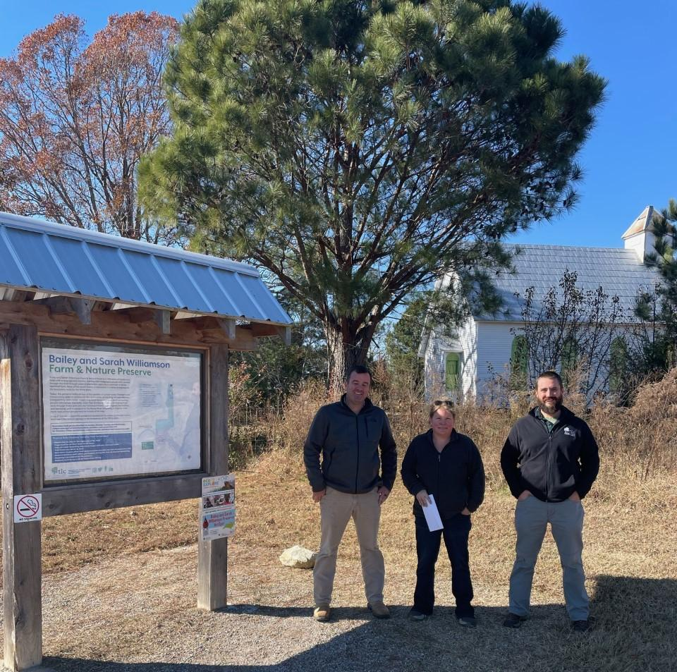

About Meridian Waste
Headquartered in Charlotte, N.C., Meridian Waste is a company defined by its commitment to servicing its customers, caring for and engaging its employees, and generating financial value for its shareholders while delivering a clean and healthy community. The company’s core waste business is centered on residential, commercial, and industrial non-hazardous waste collection and disposal. Currently, the company operates in Northeast Fla., Augusta, Ga., St. Louis, Mo., Raleigh, N.C., Greenville, S.C., Knoxville, Tenn., Blacksburg, Va., Harrisonburg, Va., and Richmond, Va. servicing more than 197,934 residential, commercial, industrial, and governmental customers. In addition to a fleet of commercial, residential, and roll-off trucks, the company operates 12 hauling companies, seven transfer stations/materials recycling facilities (MRFs), two municipal solid waste landfills, and three C&D landfills in which 946,902 tons of waste are safely disposed of annually. For more information, visit MeridianWaste.com.

Contact:
Mary O’Brien
(904) 616-5322
MObrien@MeridianWaste.com

