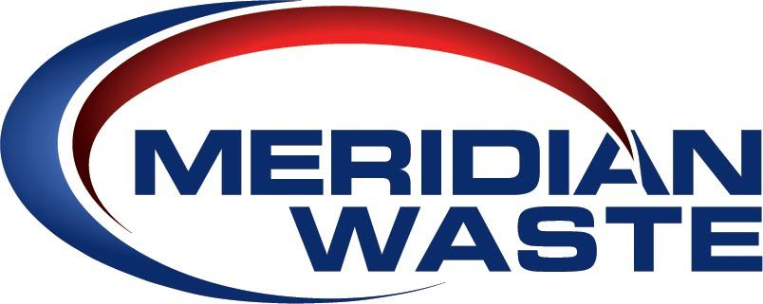

COMPANY OVERVIEW

Our Philosophy:
Meridian Waste is a company defined by our commitment to servicing our customers, caring for and engaging our employees, and generating financial value for our shareholders while delivering a clean and healthy community.
- We cannot operate successfully without an equal focus on each segment of our business.
- We are proud to be called garbage men and women with our core waste business centered on residential, commercial and industrial non-hazardous waste collection and disposal.

Locations:
The company operates nine hauling companies, seven transfer stations/MRFs, three municipal solid waste landfills, and three C&D landfills combined in the St. Louis, Mo., Richmond, Va., Blacksburg, Va., Augusta, Ga., Northeast Fla., Knoxville, Tenn., and Raleigh, N.C. marketplaces. The company is headquartered in Charlotte, N.C.

Customers:
- More than 96,651 residential, commercial, industrial and governmental customers
- 29 city and county municipal contracts

Fleet:
- 257 commercial, residential, and roll-off trucks

Disposal Volumes:
- Collects 451,900 tons of waste annually
- Safely disposes of 856,472 tons of waste in company-owned landfills

Recycling Volumes:
- Collects 9,714 tons of recyclables annually
- Processes 4,443 tons of recyclables annually in company-owned recycling facilities

Employees:
- 348 team members

