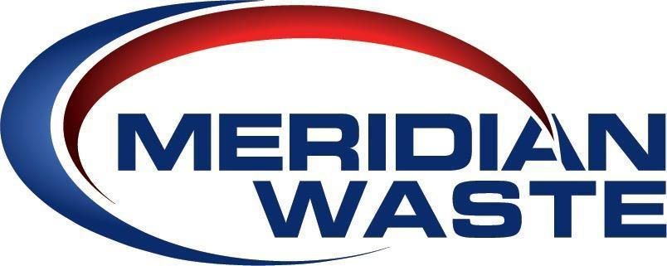

COMPANY LEADERSHIP

WALLY HALL – CEO
Walter “Wally” Hall, Jr. started his solid waste career with Browning Ferris Industries (“BFI”) in 1990 and learned the business as a true garbage man: Supervisor, Operations Manager, Manager-Trainee, General Manager, Region Operations Manager and Area President. Within his first 6 years at BFI, he oversaw 400 employees with annual revenue of $50 Million. After transitioning to Republic Services in a General Manager position, he was asked to assume the role of RVP for the Southland Waste division of Republic Services. In 2001, Mr. Hall was one of three founders of Advanced Disposal Services, Inc., which is now the fourth largest solid waste company in the U.S. Starting with three trucks, Mr. Hall grew Advanced Disposal’s operations to over $1.4 Billion in annual revenue, 5300 employees, 91 collection/hauling facilities, 45 MSW and C&D Landfills, 71 Transfer Stations and 21 recycling facilities. After completing the 2012 integration of the Advanced Disposal – Interstate Waste – Veolia Environmental acquisitions by the company, Mr. Hall left Advanced Disposal in 2014 to pursue other interests. In 2018 he became the CEO of Meridian Waste Acquisitions, LLC with the goal of once again growing a solid waste company to fill the industry need for a well-funded, nimble and both customer and employee focused independent company for the Southeast marketplace. He is a graduate of Mississippi College and former College Baseball Coach at The University of Mississippi.

DAVE LAVENDER – COO
Dave Lavender has more than 26 years of solid waste industry experience and serves as COO for Meridian Waste and is responsible for all operating aspects of the company including collection, transfer, landfill and recycling services, budgeting, capital expenditures, safety, training, acquisitions and strategic planning. He has held many operations positions with several of the largest waste companies in the U.S. including Browning Ferris Industries and Waste Management. Prior to joining Meridian Waste, Mr. Lavender spent 13 years at Advanced Disposal where he was regional vice president and oversaw 27 Hauling Companies, 14 Landfills, 18 Transfer Station, 3 Recycling Facilities and over 1,400 employees. He is a graduate from Georgia Southern University with a bachelor’s in business administration.

MARY O’BRIEN – CMO
Mary O’Brien serves as CMO for Meridian Waste and oversees marketing, government affairs and communications for the company. Her responsibilities include existing and new market area expansion via municipal contracts and acquisition integration; company communications, website, digital strategies; public relations and government and legislative affairs. Additional duties include the conversion to cloud-based technologies company-wide for multiple communication, web, development and information storage systems, upgraded online web and app services as well as implementing and auditing efficiency and automation standards and systems utilizing information technology. Ms. O’Brien’s career in the waste industry spans 21 years, and she spent the majority of her tenure with Advanced Disposal serving as CMO where she oversaw all marketing efforts with locations across seventeen states and the Bahamas with annual revenues of $1.4 Billion. Ms. O’Brien holds a bachelor’s in business administration and marketing with a minor in English from James Madison University in Harrisonburg, Virginia.

BOB MATHIS – AREA PRESIDENT, MISSOURI
Bob Mathis is Area President in Missouri and is responsible for all aspects of the Missouri solid waste collection, transfer and disposal operations, which include over 100,000 residential customers and 3,000 commercial/industrial customers.
He oversees budgetary goals and accountability, capital needs and allocation, safety, risk and revenue growth for the Missouri assets including four hauling companies, one MSW landfill, one recycling facility and two transfer stations. Acquisition activities include identification, relationship development, data acquisition and analytical review including the valuation of the candidate company. He has held district manager and general manager positions with several of the largest waste companies in the U.S. including Republic Services and Waste Corp of America. He holds a bachelor’s in business administration and management from Park University.

NATHAN GELDNER – AREA PRESIDENT, VIRGINIA
Nathan Geldner leads the Virginia operations and is responsible for all aspects including collection, transfer and disposal operations, which include over 42,000 residential customers and 2,500 commercial/industrial customers. He oversees budgetary goals and accountability, capital needs and allocation, safety, risk and revenue growth for the Virginia assets including two hauling companies, two MSW landfills, and two one recycling facilities. Mr. Geldner worked at Republic Services for 13 years starting as a mechanic and earning successive promotions to General Manager of the Northern Virginia $100M annual operations prior to joining Meridian Waste in March 2020. He is a decorated veteran of the United States Air Force and served two tours in the Middle East.

JOSH DAHER - AREA PRESIDENT, NORTH CAROLINA
Josh Daher is the Area President for North Carolina operations and is responsible for all aspects including collection, transfer and disposal operations with $12 million in annual revenues. He oversees budgetary goals and accountability, capital needs and allocation, safety, risk and revenue growth for the North Carolina assets including one hauling company, three transfer stations, and one C&D landfill. Mr. Daher has been with Meridian Waste for three years and most recently ran operations in the Knoxville, Tennessee area. Mr. Daher joined The Company in 2017 as the Director - Human Resources & Safety and in his second year was promoted to General Manager of the Company’s newly acquired Tennessee Disposal assets. He implemented the Tennessee Hauling operations as a start-up and built the business into a $2.2 million marketplace. Prior to the environmental services industry, he served as a high school educator and athletic director coaching of young adults in baseball, basketball, and football.

www.MeridianWaste.com ∙ 770.691.6350

