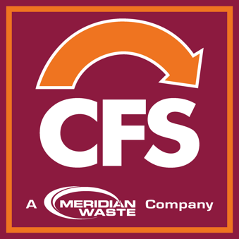

Tri-City Landfill To Appeal Landfill Permit Revocation
DEQ Director Disregards Hearing Officers Recommendations

PETERSBURG, Va. (October 17, 2019) – Container First Services (CFS), a wholly-owned subsidiary of Meridian Waste, an integrated, non-hazardous solid waste services company, announces plans to appeal the October 15, 2019 case decision and special order issued by Department of Environmental Quality (DEQ) Director David Paylor affecting the Tri-City Landfill located in Petersburg, Va.

Given that DEQ was the prosecuting entity, the DEQ Director’s decision to revoke the landfill operating permit for the Tri-City Landfill is not surprising. The Tri-City Landfill is operated by The CFS Group Disposal & Recycling Services, LLC, a subsidiary of Meridian Waste Virginia, LLC since February 2017. DEQ’s decision disregards the significant investment Meridian Waste has made at the Landfill since February 2017, it neglects the facility’s substantial financial impact upon the City of Petersburg, it discounts the waste needs of the localities participating in the Central Virginia Waste Management Authority, and it ignores several of the recommendations of the Administrative Hearing Officer.

Tri-City Landfill will be filing an appeal with the rules of the Supreme Court of Virginia (Rule 2A:2). The special order and appeal process does not interfere with the company’s solid waste collection processes, contracts or the operation of the municipal solid waste transfer station located adjacent to the landfill. CFS will continue to provide environmental services to its customers and to keep the community clean and healthy.
This will be a long legal process that Meridian Waste is committed to winning. The landfill is a vital infrastructure asset that benefits the greater community. It has been operated in compliance with DEQ orders and regulations. The company looks forward to proving this in the objective forum provided by a court of law.

About Meridian Waste
Headquartered in Charlotte, N.C., Meridian Waste is a company defined by its commitment to servicing its customers, caring for and engaging its employees, and generating financial value for its shareholders while delivering a clean and healthy community. The company’s core waste business is centered on residential, commercial, and industrial non-hazardous waste collection and disposal. Currently, the company operates in St. Louis, Mo., Richmond, Va., Blacksburg, Va., Augusta, Ga., Northeast Florida and Knoxville, Tenn., servicing more than 119,792 residential, commercial, industrial and governmental customers. In addition to a fleet of commercial, residential, and roll-off trucks, the company operates two transfer station, three recycling facilities, three municipal solid waste landfills and two C&D landfills in which 890,676 tons of waste are safely disposed annually. For more information, visit MeridianWaste.com.

